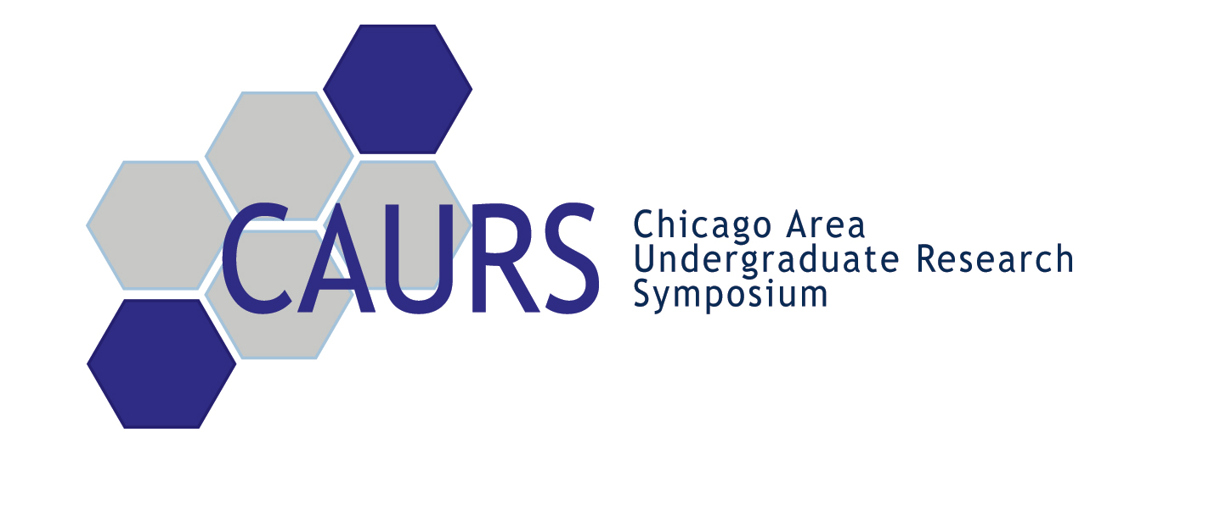

Dear Faculty Member/Dignitary,

This past Saturday on April 1st was the second annual Chicago Area Undergraduate Research Symposium, held at the Chicago Cultural Center. This year’s Symposium was marked with nearly 100 student presenters, and nearly 250 total attendees. The event was a huge success on all accounts, and an improvement on last year’s event in all respects. We are looking forward to watching the development and expansion of CAURS in future years.
All of the research presented at CAURS this year was astounding. Several projects and presentations in particular stuck out, and to those students we presented awards. The student award winners are listed below:

Engineering, Physics, Math:
Poster Award: Jesse Collins - IIT
Poster Award: James Rondinelli - NU
Psych/Biology:
Poster Award: Kimberly Lekwa - Loyola
Poster Award: Katherine Sharrock - NU
Chemistry:
Poster Award: Marie-Justine Bell - U of C
Poster Award: Michael Kozminski – NU

Oral Presentation Award: Michael Kozminski – NU
President’s Award Marsela Jorgolli – U of C
Research Proposal Award: Rachael Kim - NU

Thank you for your support of the 2006 Chicago Area Undergraduate Research Symposium. We hope you thoroughly enjoyed CAURS this year and will continue to help CAURS grow in years to come.

Sincerely,
CAURS Inter-School Board Committee

